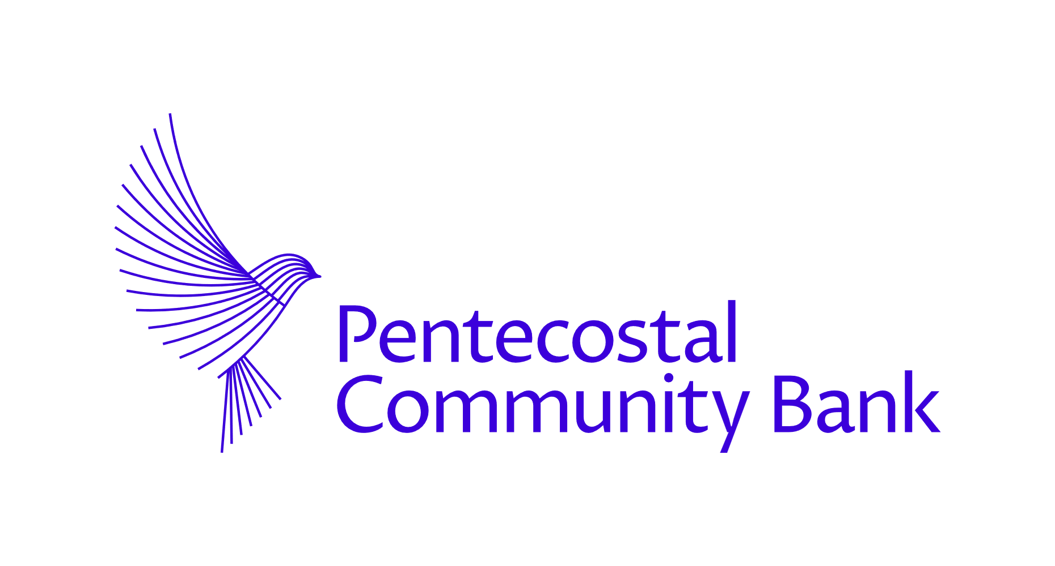MONEYWISE

Building Financial Freedom and Resilience

Participant Workbook (16–25 Years)
Pentecostal Community Bank

Welcome
Welcome to the Moneywise programme.
Moneywise is about more than money.
It is about:
- wisdom,
- discipline,
- purpose,
- resilience,
- integrity,
- and building a secure future.
This workbook belongs to you.
Use it to:
- reflect,
- take notes,
- complete exercises,
- record ideas,
- and build your own financial action plan.

Course Values

The Moneywise Person
A Moneywise person:
- Thinks long term
- Lives with wisdom
- Uses money responsibly
- Practices self-control
- Plans for the future
- Avoids harmful financial behaviour
- Values people above possessions
- Builds community and not just personal success

SECTION 1 — MONEY AND LIFE

Key Scripture
“How much better to get wisdom than gold; to choose insight rather than silver.”
Proverbs 16:16

Reflection Exercise

What does financial freedom mean to me?
Write your thoughts below.

Discussion Notes

Why do people struggle with money today?

Financial Resilience
Financial resilience means:
- Recovering from setbacks
- Preparing for emergencies
- Building long-term stability
- Staying in control financially

Personal Reflection

What financial worries affect young people most today?
Tick any that apply.
□ Cost of living □ Housing □ Debt □ Social media pressure □ Unemployment □ Relationships □ Family responsibilities □ Mental health □ Lifestyle expectations □ Other
Notes:

SECTION 2 — SPENDING AND SELF-CONTROL

Key Scripture
“…add to your faith goodness; and to goodness knowledge; and to knowledge, self-control…”
2 Peter 1:5–7

Your Emotions and Your Money

Reflection
What emotions influence your spending most?
□ Stress □ Rewarding myself □ Boredom □ Peer pressure □ Social media □ Fear of missing out □ Wanting status □ Loneliness □ Celebration □ Other
Notes:

Social Media, Status and Money

Discussion
“Social media makes people spend money they don’t have to impress people they don’t know.”
Do you agree?
Why or why not?

Reflection Exercise

Are we spending for our future — or for appearances?
Write your thoughts.

Needs vs Wants

Group Activity
List three NEEDS and three WANTS.
NEEDS | WANTS

Budgeting Exercise

My Monthly Budget
INCOME | £
Job
Family Support
Benefits
Other
TOTAL

SPENDING | £
Travel
Food
Phone
Clothes
Entertainment
Subscriptions
Giving
Savings
Other
TOTAL

Good Habits Challenge
Tick habits you want to improve.
□ Save regularly □ Think before buying □ Reduce impulse spending □ Delay gratification □ Budget monthly □ Spend less on social media trends □ Build emergency savings □ Give intentionally

SECTION 3 — DEBT, CREDIT AND FINANCIAL TRAPS

Discussion Exercise

“Debt is a bad thing and my aim is to live debt free.”
Do you agree?

Good Debt vs Bad Debt
GOOD DEBT | BAD DEBT

Student Loans Reflection

What are the advantages and disadvantages of student loans?
ADVANTAGES | DISADVANTAGES

Credit Health Checklist
Tick what helps build healthy credit.
□ Pay on time □ Keep balances low □ Avoid too many applications □ Maintain stable addresses □ Use credit responsibly □ Avoid maxing out cards

Case Study Notes

What should someone do when they are struggling financially?

SECTION 4 — SAVING AND BUILDING WEALTH

Key Scripture
“The wise man saves for the future, but the foolish man spends whatever he gets.”
Proverbs 21:20

Savings Goals Exercise

What are you saving for?
GOAL | SHORT / LONG TERM | TARGET AMOUNT

Emergency Fund Planning

Why is an emergency fund important?

Saving vs Investing

In your own words:
What is the difference between saving and investing?

Investing Reflection

Which investing habits are most important?
□ Starting early □ Investing regularly □ Thinking long term □ Diversifying □ Patience □ Avoiding hype
Why?

SECTION 5 — CRYPTO AND SCAMS

Cryptocurrency Discussion

Opportunity or Risk?
What attracts young people to cryptocurrency?

Scam Awareness Exercise

Spot the Warning Signs
Tick warning signs of scams.
□ Pressure to act quickly □ Guaranteed returns □ Requests for passwords □ “Too good to be true” offers □ Fake celebrity endorsements □ Crypto payment requests

Reflection

Why do scammers target emotions?

SECTION 6 — PURPOSE, CHARACTER AND COMMUNITY

Reflection

What kind of person do I want money to help me become?
□ Generous □ Disciplined □ Responsible □ Peaceful □ Wise □ Community-minded □ Independent □ Helpful to family □ Ethical
Notes:

Sharing and Community

Ways we can share:
□ Giving □ Volunteering □ Supporting others □ Tithing □ Mentoring □ Using our skills

Key Money Guidance

Tick the principles you want to apply in your life.
□ Spend less than I earn □ Pay myself first □ Build emergency savings □ Avoid high-interest debt □ Differentiate needs from wants □ Use credit wisely □ Think long term □ Have a financial plan

My Moneywise Action Plan

ONE thing I will STOP doing:

ONE thing I will START doing:

ONE financial goal for the next 12 months:

Final Reflection

Your financial habits today shape your future tomorrow.
What does this statement mean to you?

The Pentecostal Community Bank
We believe in the economic empowerment of our members so that they can fulfil their potential and achieve their aspirations.

Stay Connected
www.pcbank.co.uk
info@pcbank.co.uk
0333 355 1022
Instagram: @pentecostalcommunitybank
TikToc: @pentecostalcommunitybank

Certificate of Completion
Participants who complete the Moneywise programme will receive a digital certificate of participation.

